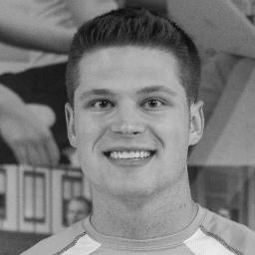Web Editor Jake Alsko is a journalism major and public relations minor at Oakland University. Jake enjoys being around his family and friends, listening to music, playing sports and having civil arguments.

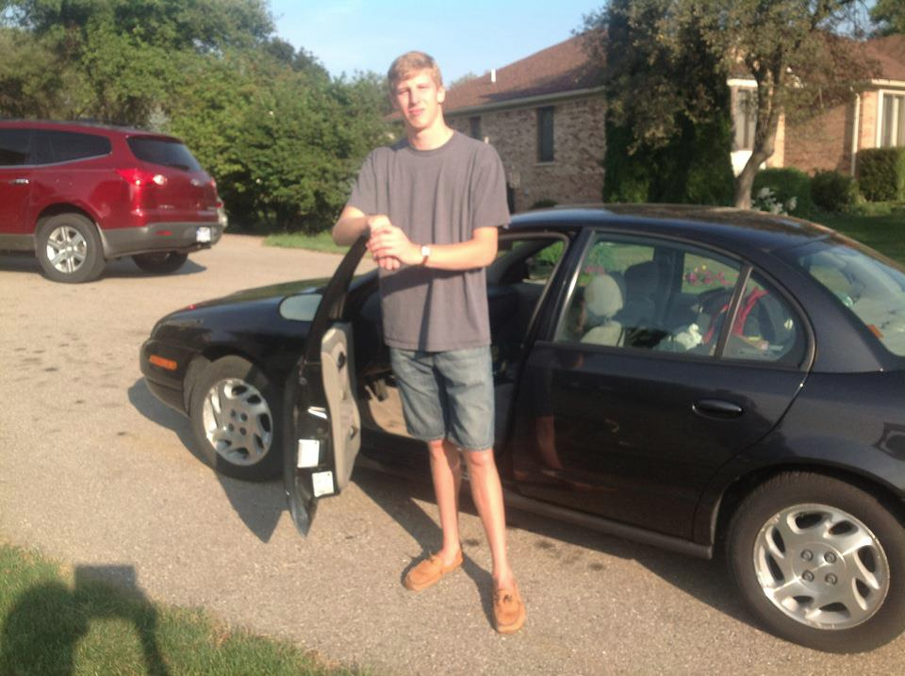Hello! I’m Andrew Wernette, the Life, Arts & Entertainment Editor at The Oakland Post. I oversee the section of the Post that strives to capture an intimate look at OU’s people and culture. I’m a senior English major with minors in journalism and Chinese, and I like to read. When not helping to put the paper together, I like to relax, go on adventures and ponder life’s questions. One day, I will go off to travel the world and never stop.



Kaleigh Jerzykowski, Staff Reporter, junior journalism major

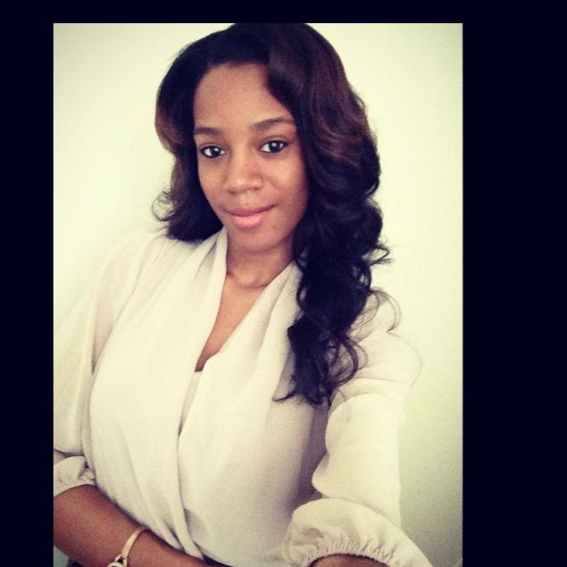“I've been with the Oakland Post since fall of 2014 and I love the fast-paced environment. Yoga and writing are my passions in life, and I'm so lucky that I get to do both every single day!”

Jasmine French, Staff Reporter, senior journalism major, communication minor

"Writing for the Oakland Post has been such a refreshing experience as a student. I've been granted the opportunity to do something I enjoy apart from daily responsibilities, while connecting with great people. I call it a splash of color on a blank page.”

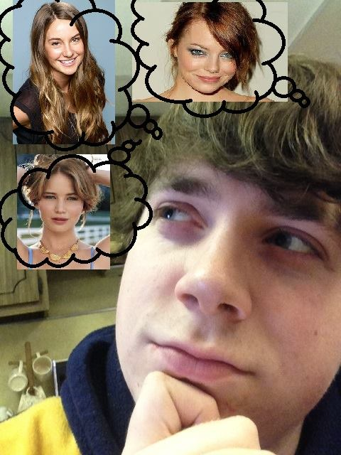

Scott Davis, Staff Reporter, junior journalism major

"Hey! I have been writing for the Oakland Post since April 2014 and have had a blast so far. Along with my journalism major, I am a Cinema Studies minor so film is a huge passion of mine. Christopher Nolan is my idol."

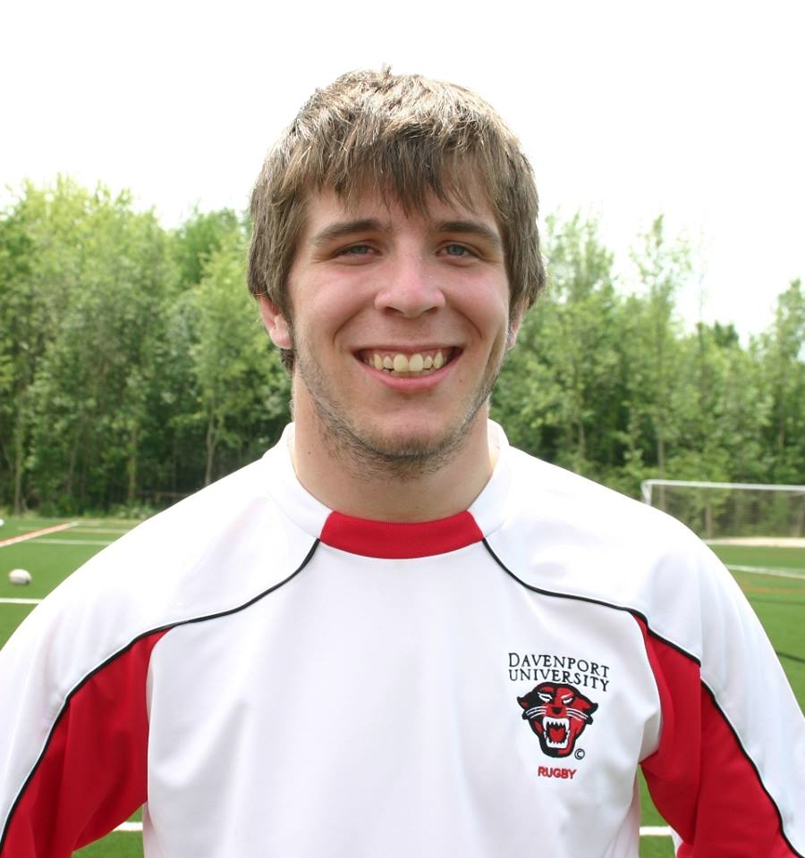Joseph Bach, Staff Intern, junior journalism major

“Joe Bach was raised in Birmingham Michigan and attended Birmingham Seaholm before graduating from Troy High School in 2009. He originally accepted a rugby athletic scholarship to Davenport University winning D1-AA National Championship in 2011 and a D1 National Championship in 2012 before transferring to Oakland University to study journalism and broadcasting.”

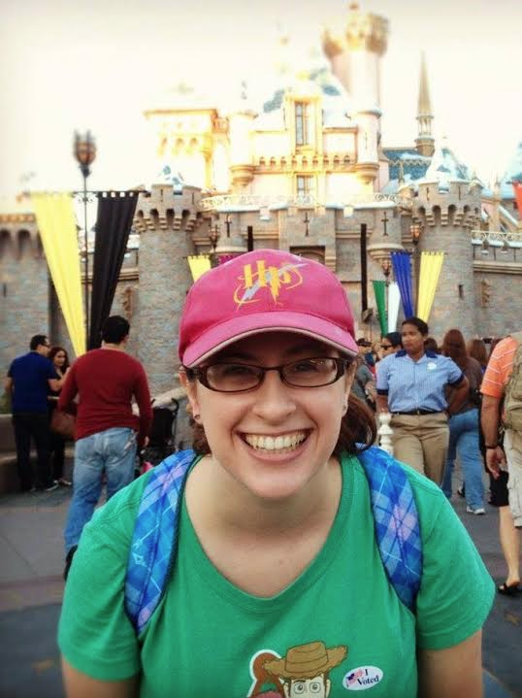

Morgan Dean, Copy Editor, Cinema Studies and Creative Writing double major

“I studied for a year at Kalamazoo College for biology and European history than took a few years off from school, in which time I participated in the Disney College Program internship at Disneyland and California and worked at Disneyland for two years. I also studied abroad in Oxford, England this past summer and absolutely LOVED it! I love Thai and Indian food, mint chocolate chip ice cream, fantasy adventure and historical fiction books, James Cagney movies, my cat Minerva, and my dream is to travel around the world and be a story creator for Pixar.”